Office Use Only
___Application
___Initialed/ Signed Rules
___ Payment
___ Permit/Receipt Issued
___________________
Date Receipt Pkt. Issued
Or Mailed

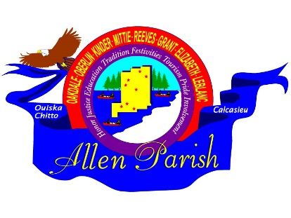
APPLICATION
ALLEN PARISH TOURIST COMMISSION
RE-THUNK JUNK FLEA MARKET TRAIL
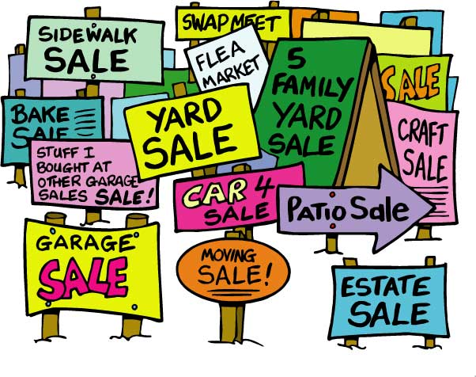
Allen Parish Tourist Commission
8904 Hwy 165 / P O Box 1280
Oberlin, LA 70655
888-639-4868

OCTOBER 16-17, 2026

NAME: __________________________________________________________________________________

ADDRESS: _______________________________________________________________________________

CITY: ___________________________________________ STATE: ____________________ZIP____________

YOUR PHONE:______________________ EMAIL:_______________________________________________

EMERGENCY CONTACT PERSON: _____________________________________________________________

PHONE: ______________________

PLEASE BRIEFLY DESCRIBE WHAT YOU WILL BE SELLING:
______________________________________________________________________________________________________________________________________________________________________________________________________________________________________________________________________________

PLEASE CHECK LOCATION: ___Kinder Cultural Ctr. ___ Oberlin Vet’s Park

PLEASE CHECK SPOT(S) BELOW SUBMIT PAYMENT BY MONEY ORDER ONLY

1. CAR or REG. TRUCK W/TABLE 2. CAR or REG. TRUCK WITH TRAILER 3. RV OR EQUIVALENT
10X10 $20.00 10X20 $35.00 10X30 $45.00

PLEASE INCLUDE: PAYMENT,
APPLICATION, INITIALED & SIGNED RULES & REGULATIONS FORMS
MAIL COMPLETED PACKET TO:
ALLEN PARISH TOURIST COMMISSION
P O BOX 1280
OBERLIN, LA 70655

___

