Office Use Only
___Application
___Initialed/ Signed Rules
___ Payment
___ Permit/Receipt Issued
___________________
Date Receipt Pkt. Issued
Or Mailed

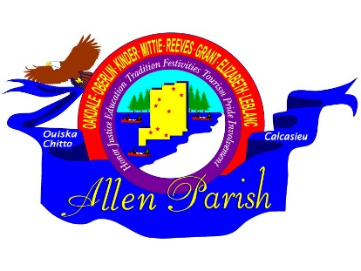
APPLICATION
ALLEN PARISH TOURIST COMMISSION
RE-THUNK JUNK FLEA MARKET TRAIL
Allen Parish Tourist Commission
8904 Hwy 165 / P O Box 1280
Oberlin, LA 70655
888-639-4868

OCTOBER 20-21, 2023

NAME: __________________________________________________________________________________

ADDRESS: _______________________________________________________________________________

CITY: ___________________________________________ STATE: ____________________ZIP____________

PHONE:______________________ EMAIL:____________________________________________________

EMERGENCY CONTACT PERSON: _____________________________________________________________

PHONE: ______________________

PLEASE BRIEFLY DESCRIBE WHAT YOU WILL BE SELLING:
_______________________________________________________________________________________

_______________________________________________________________________________________
Office Use Only
FOOD VENDOR LOCATION: _____________________PRE-REGISTRATION DATE: ___________________

PLEASE CHECK LOCATION: ___Kinder Welcome Ctr. ___Vet’s Park Oberlin ___Leatherwood Museum Oakdale
PLEASE CHECK SPOT(S) BELOW SUBMIT PAYMENT BY MONEY ORDER ONLY

1. CAR or REG. TRUCK W/TABLE 2. REG. TRUCK WITH TRAILER 3. RV OR EQUIVALENT
10X10 $15.00 10X20 $30.00 10X30 $45.00

PLEASE INCLUDE: PAYMENT,
APPLICATION, INITIALED & SIGNED RULES & REGULATIONS FORMS
MAIL COMPLETED PACKET TO:
ALLEN PARISH TOURIST COMMISSION
P O BOX 1280
OBERLIN, LA 70655

