Office Use Only
___Payment
___Application
___Initialed/ Signed Rules
___ Permit/Receipt Issued
___________________
Date Receipt Pkt. Issued
Or Mailed

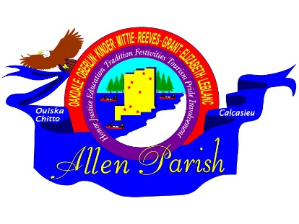
APPLICATION
ALLEN PARISH TOURIST COMMISSION
RE-THUNK JUNK FLEA MARKET TRAIL
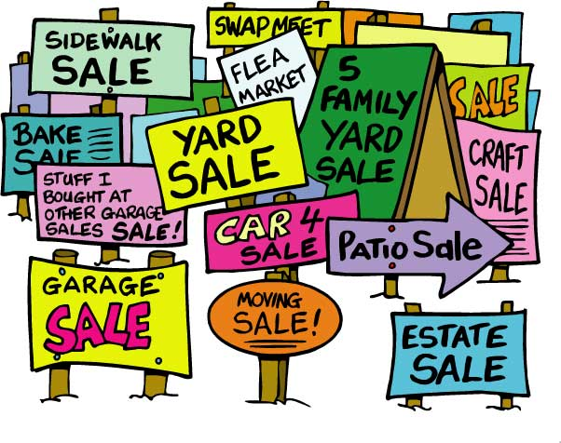
Allen Parish Tourist Commission
8904 Hwy 165 / P O Box 1280
Oberlin, LA 70655
888-639-4868

OCTOBER 15-16, 2021

NAME: __________________________________________________________________________________

ADDRESS: _______________________________________________________________________________

CITY: ___________________________________________ STATE:____________________ZIP____________

PHONE:______________________ EMAIL:____________________________________________________

EMERGENCY CONTACT PERSON: _____________________________________________________________

PHONE: ______________________

PLEASE BRIEFLY DESCRIBE WHAT YOU WILL BE SELLING:
_______________________________________________________________________________________

_______________________________________________________________________________________
Office Use Only
FOOD VENDOR LOCATION: _____________________PRE-REGISTRATION DATE: ___________________

PLEASE CHECK LOCATION: ___Kinder Welcome Ctr. ___Vet’s Park Oberlin ___Leatherwood Museum Oakdale
PLEASE CHECK THE FEE/S THAT APPLIES BELOW:
1. CAR or REG. TRUCK WITH TABLE $15.00 2. REG. TRUCK WITH TRAILER $30.00 3. RV $45.00

PLEASE FILL OUT TOTAL FEES IN BLANK: TOTAL DUE: $ __________________
MAKE MONEY ORDERS PAYABLE TO:
Allen Parish Tourist Commission
MAIL FEE AND COMPLETED PACKET TO:
ALLEN PARISH TOURIST COMMISSION
P O BOX 1280
OBERLIN, LA 70655

PLEASE INCLUDE:
APPLICATION, INITIALED & SIGNED RULES & REGULATIONS FORMS, AND MONEY ORDER PAYMENT!

